**21CY682 – Secure Coding lab - I**

**Assignment Topic: C Programming**

**Register Number: CYS22005**

**Date: 27/9/2022**

**Name: B.Shebu**

1. Write a C Program to authenticate a user using username and password. Have a list of 5 usernames and passwords in an array. If the entered username and password matches with the username / password combination in the array, then print as “Authentication Successful” else print “Authentication failed , try again”. The user is permitted to enter the wrong password only 3 times. If the user exceeds the limit, then print “Limit exceeded. Try later”.

**Code:**

#include<stdio.h>

#include<string.h>

int main()

{

char usr[10][10] = {"user1", "user2", "user3", "user4", "user5"};

char pass[10][10] = {"pass1", "pass2", "pass3", "pass4", "pass5"};

char username[10], password[10];

int attempt = 3, flag = 0;

while(attempt > 0)

{

printf("\nRemaining Attempts: %d\n\n", attempt);

printf("Enter the Username: ");

scanf("%s",username);

printf("Enter the Password: ");

scanf("%s",password);

for(int i=0; i<5; i++)

{

if(strcmp(usr[i], username) == 0 && strcmp(pass[i], password) == 0)

{

printf("\nAuthentication Successful\n");

flag = 1;

break;

}

}

if(!flag)

{

printf("\nAuthentication failed , try again\n");

attempt--;

}

else

break;

}

if(!flag)

printf("\nLimit exceeded. Try later\n");

return 0;

}

**SNAPSHOTS :**

Case1 – Authentication successful

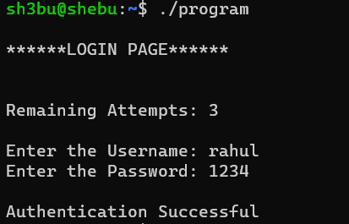

Case 2 – Authentication failed

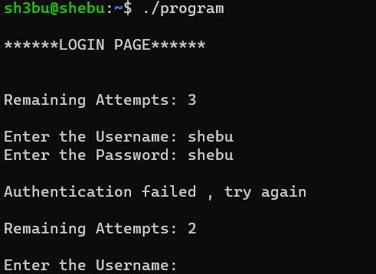

Case3 – Number of attempts exceeded

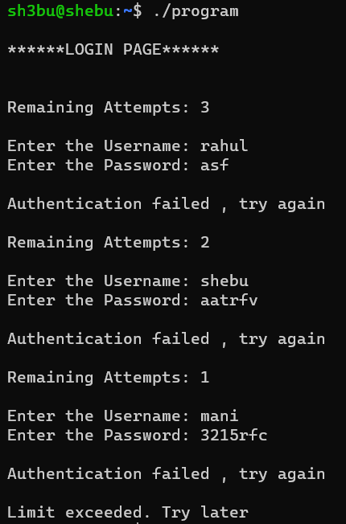

1. Write a C program to create a password strength meter. A password is said to be strong if it is at least 8 characters long and contains at least one lowercase character, one uppercase character, one special character ( !@#$%^&*()) and one digit. The program should obtain a password string from the user and compute the password strength (in percentage) based on the 5 criteria listed above for strong passwords.

Code –

#include <stdio.h>

#include<ctype.h>

#include<string.h>

int main()

{

char pass[30];

printf("Enter your Password \n");

scanf("%s",pass);

int len,percentage=0,i,upper=0,lower=0,digit=0,spchar=0;

len=strlen(pass);

if(len>=8)

{

percentage=percentage+20;

}

for(i=0;i<len;i++)

{

if(isupper(pass[i]))

{

upper++;

}

else

if(islower(pass[i]))

{

lower++;

}

else

if(isdigit(pass[i]))

{

digit++;

}

else

{

spchar++;

}

}

if(upper)

{

percentage=percentage+20;

}

if(lower)

{

percentage=percentage+20;

}

if(digit)

{

percentage=percentage+20;

}

if(spchar)

{

percentage=percentage+20;

}

printf("Your Password Strength is: %d",percentage);

return 0;

}

**Snapshot –**

**Case 1 – All lowercase characters**

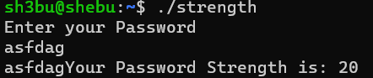

**Case 2 – All uppercase characters**

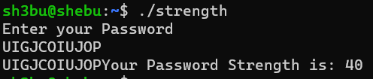

**Case 3 – Both upper and lower case characters**

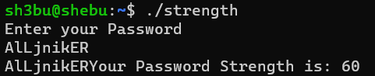

**Case 4 – All characters are digits**



**Case 5- All characters are special characters**

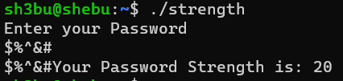

**Case 6– Contains lowercase , uppercase , special characters and digits**

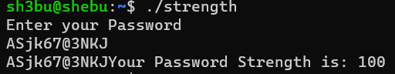

1. Write a C program to generate strong passwords of a length specified by the user.

**Code –**

#include<stdio.h>

#include<stdlib.h>

#include<time.h>

int main()

{

char alphabet[100] = "abcdefghijklmnopqrstuvwxyzABCDEFGHIJKLMNOPQRSTUVWXYZ";

char number[15] = "0123456789";

char sym[15] = "^$%()&@*!#";

srand(time(NULL));

int i,n, a, b, c;

while(n < 8)

{

printf("Enter the number of characters: ");

scanf("%d", &n);

printf("Enter a number which is less than 8");

}

printf("\nThe Generated Strong Password: ");

for(int i=0; i<n/3; i++)

{

a = (rand()%51);

b = (rand()%9);

c = (rand()%9);

printf("%c%c%c", alphabet[a], number[b], symbol[c]);

}

if(n%3 == 2)

{

a = (rand()%51);

b = (rand()%9);

printf("%c%c", alphabet[a], symbol[b]);

}

if(n%3 == 1)

{

a = (rand()%51) + 1;

printf("%c", alphabet[a]);

}

printf("\n");

return 0;

}

**Snapshots –**

